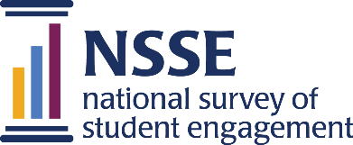

Lessons from the Field — Dispatch #2

From Student Comments to More
Inclusive Practices

MARIAN University

A theme began to emerge in the students’ comments around the topic of diversity, equity, and inclusion. Students expressed concerns related to who is valued, what is valued, and the importance of reflecting more diverse identities on campus.
.

At Marian University, assessment and learning are viewed as inextricably linked, so much so that the Director of Educational Assessment, Dr. Tony Ribera, works within Marian’s Center for Teaching and Learning and serves on the Teaching and Learning Committee along with faculty and staff from across departments. This committee includes an assessment activities subcommittee whose members serve as key players in examining and sharing NSSE results and information.

Tasked with the review of Marian’s NSSE 2019 results, the assessment activities subcommittee chose to focus on both the quantitative and qualitative data during multiple subcommittee meetings. Subcommittee members used this time as well as a shared Canvas page to read and discuss the NSSE data and reports, including students’ comments in response to the survey’s open-ended prompts. Although these comments were viewed and analyzed in an informal manner, key themes and trends emerged from them that were still quite impactful.
While the quantitative data suggested that students were engaging with diverse peers relatively often, the qualitative data—the student comments—provided another dimension and a more detailed picture of diversity on campus. The open-ended prompt Marian students received for their comments was:
“What one change would most improve the educational experience at this institution?”
As members of the assessment activities subcommittee viewed the approximately 200 responses, a theme began to emerge around the topic of diversity, equity, and inclusion.
Marian University
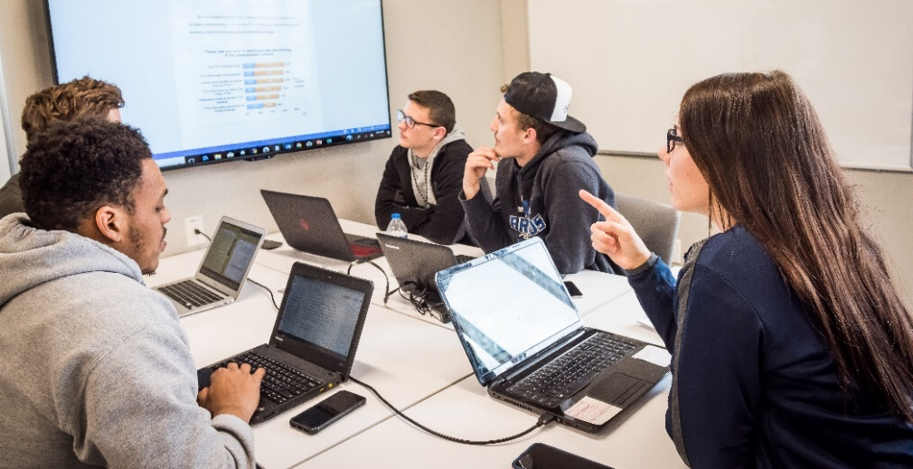
In This Dispatch
From Student comments to more inclusive practices
Marian University
playing in the sandbox for student success
Rhode Island University
Using data to understand and serve a unique student population
Indiana University Northwest
CREATING READABLE, MEANINGFUL AND ACTIONABLE NSSE AND FSSE REPORTS
Florida Agricultural and Mechanical University
This Dispatch is a supplement to NSSE’s multi-volume series Lessons from the Field.
For more institution examples, see Volume 4 as well as other volumes in the series and the searchable collection of all examples online: nsse.indiana.edu/links/lessons
Suggested citation: National Survey of Student Engagement. (2020). Lessons from the Field—Dispatch #2. Bloomington, IN: Center for Postsecondary Research, Indiana University School of Education.

Students expressed concerns related to who is valued, what is valued, and the importance of reflecting more diverse identities on campus.
It became clear to the subcommittee that Marian University could do and should do better by its students and—based on student comments—that many of these changes were possible to implement.
Since the review and presentation of NSSE 2019 data, several changes have occurred on the Marian campus related to inclusivity and learning. The institution has established a new framework, created by faculty and staff, to outline what a learning experience at Marian should look like and to guide educators in creating more impactful learning. This new framework incorporates inclusive practices such as ensuring students feel valued and respecting diverse perspectives.
The Center for Teaching and Learning has also developed a professional development certificate focused on creative inclusive experiences. Those interested in receiving the certificate are required to participate in four events around topics such as implicit bias and inclusive pedagogy. Thus far, over 100 educators at the institution, including faculty and staff, have registered.

These initiatives have not been limited to introducing strategies for how students learn but also include new strategies for assessing inclusivity in teaching. More recently, the university has emphasized inclusive teaching in its annual program assessment planning and reporting process as well as in its seven-year self-study process. Each program is developing its own assessment plan that will ask explicitly what the program is doing to foster inclusive classroom environments.

Throughout this process, strong connections have been created between faculty and staff. Student affairs professionals have utilized their expertise to facilitate workshops and to assist faculty in understanding concepts related to diversity, equity, and inclusion. Although difficult conversations have occurred during the workshops, the facilitators have been able to expertly handle these situations and to help participants grow in their understanding of inclusivity in the classroom. These new initiatives have been helpful in creating strong relationships across student affairs and academic affairs.

The Teaching and Learning Committee and Marian University as a whole have worked diligently to respond to students’ feedback and to make concrete changes to the campus. Utilizing quantitative and qualitative NSSE results allowed for a more nuanced and intentional approach to teaching and learning—with a stronger focus on inclusivity.

Creating Readable, Meaningful & Actionable NSSE & FSSE Reports

Florida Agricultural and mechanical university
Florida Agricultural and Mechanical University (FAMU), a Historically Black College and University (HBCU), found a way to disseminate their NSSE and FSSE results in an easy-to-read, meaningful format that engaged a range of campus entities. In fact, FAMU’s inclusive use of NSSE and FSSE results was a hallmark of the institution’s comprehensive approach to assessment that distinguished them as a 2020 Excellence in Assessment Designee.

FAMU’s approach to sharing NSSE and FSSE results exemplifies the importance of tailoring reports and using data to inform productive campus conversations. Specifically, their Office of University Assessment created two reports, “Results of the 2017 National Survey of Student Engagement” and “Comparative Analysis of the 2017 NSSE and 2018 FSSE” based off their NSSE 2017 and FSSE 2018 results. These companion reports include an executive summary, introduction to the NSSE and FSSE, a comparative summary of student engagement results, population demographics of the faculty, select item comparisons, and a thematic summary of open-ended items.
NSSE Student Comments (open-ended items)
At the end of the core survey, students are invited to express their opinions about their college learning experience in a space for up to 5,000 characters. Institutions can choose one of four open-ended prompts:
- If you have any additional comments or feedback that you’d like to share on the quality of your educational experience, please enter them below.
- What has been most satisfying about your experience so far at this institution, and what has been most disappointing?
- Please describe the most significant learning experience you have had so far at this institution.
- What one change would most improve the educational experience at this institution, and what one thing should not be changed?
Students’ confidential, candid reflections on their own college experience can be an asset in survey research and assessment. Taking the time to review student comments gives voice and agency to students at the institution and recognizes the time and energy put into providing a thoughtful response. Student comments also complement quantitative results and expand assessment to include what students view as important in their own lives.
View NSSE ‘s archived webinar on using student comments
nsse.indiana.edu/support-resources/webinars

Highlights include that FAMU first-year students and seniors perceived higher levels of engagement with faculty when compared to other students from institutions in the Peer and Aspirational category, Carnegie Classification category and NSSE 2016 & 2017 aggregate. The NSSE & FSSE results show that faculty perceived students to spend considerably less time preparing for class and more time in leisure activities; while students conversely reported that they spent considerable time preparing for class and less time in leisure activities, resonated with several campus audiences. These selected findings quickly helped campus partners identify how they compare to other peer institutions, and the combined NSSE & FSSE results showed areas of congruence and misalignment in perception between faculty and students.
The reports also explain the Engagement Indicators and High-Impact Practices and highlighted the select item comparisons for the five questions on which first-year and senior students scored the highest and the five questions on which they scored the lowest relative to students in the comparison group. The combined NSSE & FSSE report discussed how the comparison results contain a great deal of information; but rather than analyzing and reporting all items, the report intentionally highlighted key indicators of areas of growth or improvement as reported by both faculty and students.

Florida Agricultural and Mechanical University, Lee Hall Auditorium
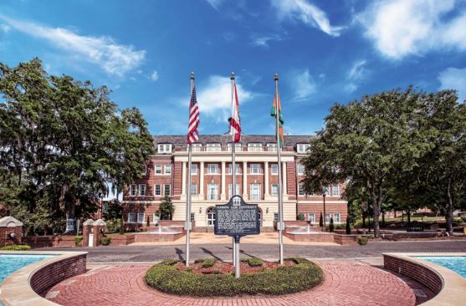
These reports provide a great summary of FAMU’s NSSE and FSSE results and provide a model for other campuses as they work to share their results and engage campus partners in using evidence to improve.

Playing in the Sandbox for Student Success

University of rhode island
Ensuring student success is a top priority at the University of Rhode Island (URI), where since 2003 NSSE has been used to measure students’ perceptions of the institution. More recently, URI’s Vice President of Enrollment Management formed the Student Success Team, bringing together about 30 faculty, staff, and administrators from across multiple departments and disciplines who were to focus on removing structural impediments to student learning and improving graduation rates. Two initiatives the team has already implemented are curriculum maps for every major and the Take 5, Finish in 4 program that encourages students to complete five three-credit courses every semester in order to graduate in four years. Measuring the effectiveness of these programs requires a comprehensive assessment plan that includes NSSE data.

Recognizing the contribution of people’s time and resources while meaningfully sharing and utilizing results is also a top priority at URI. The Student Success Team has been intentionally working to create a deeper understanding of data and action items among individual faculty and across the institution to improve student learning. A new team initiative, called the Sandbox, was implemented to bring together educators from across campus to dig into URI’s NSSE results.
The Sandbox, emulating the idea of playing with the data, brought together approximately 40 faculty and staff to learn more about NSSE and student assessment. The Sandbox took place in an “active classroom” within the institution’s library—a space equipped with a dozen electronic whiteboards connected to laptops in the room, allowing small groups of participants to play with the data, take notes, and present their own findings.

The Sandbox session began with an introduction to NSSE, including a description and explanation of the items, survey themes, Engagement Indicators, and additional survey questions. After familiarizing participants with the survey, members of the Student Success Team shared examples of results the team had already analyzed. To keep participants engaged, facilitators shared graphs of their analysis and asked participants to interpret the data, to share their conclusions, and to ask any further questions they may have had about the data.

One facilitator example focused on a survey item on how students use their time. Findings suggested class level was not a significant factor, with both first-year and senior students averaging 15 hours per week on coursework outside of class. To showcase opportunities for digging deeper into results, facilitators disaggregated data further by major, finding nursing majors actually above average in hours spent on coursework. This walk-through helped the faculty follow the data down to deeper and deeper levels to gain more confidence for their own analyses.
At the University of Rhode Island, data are not seen as stagnant but as opportunities to better understand the institution and its students.
Once faculty and staff had a chance to familiarize themselves with the assessment process and the NSSE survey, they were provided an opportunity to complete an analysis of their own. The Student Success Team created a spreadsheet containing all the URI data from the NSSE core survey as well as two modules, First-Year and Senior Transitions and Academic Advising. Participants were able to copy and paste cells into a separate tab that updated result charts automatically. The goal was to have everyone, in small groups, browse the survey to find questions related to their particular area of interest, update the spreadsheet, and write conclusions on the whiteboards. At the end of the 90 minutes, participants felt more comfortable with their understanding of assessment data and more confident in their abilities to incorporate assessment into their own practice.
The Sandbox was a huge success. To maintain the assessment momentum, the Student Success team has offered additional incentives. One invited attendees to come up with a research question answerable by NSSE data and to present it to the assessment office to receive funding for their research. Individuals or groups who receive this funding are then asked to present their findings to other campus constituents.

The University of Rhode Island is a data-informed institution, where data are not seen as stagnant but as opportunities to better understand the institution and its students. By creating an active culture of assessment, URI is turning rich data about their students into actionable knowledge to improve the campus community.
*Acknowledgement: After contributing to this account of NSSE data use, Dr. Gary Boden passed away in July 2020. At the time, he was Senior Information Technologist in the Office of Institutional Research at the University of Rhode Island.

Using Data to Understand & Serve a Unique Student Population

Indiana University Northwest
Every institution is unique, with its own story to tell. While many schools see NSSE as a comparative tool to measure themselves against similar institutions, Indiana University Northwest recognizes the need to contextualize their data in ways that help tell their story and make improvements to their campus. Located in Gary, Indiana, IU Northwest is a regional commuter campus within the IU system, serving approximately 3,800 students. As a commuter campus, how IU Northwest promotes the survey and what it looks for in the data, is distinct.
Instead of trying to change the behaviors of students whose lives are busy with competing priorities such as work and family, the need is about meeting students where they are—in the classroom.
John Novak, assistant vice chancellor of institutional effectiveness and research, has found success partnering with others at IU Northwest, who then provide information and promote the survey to their deans, departments, faculty, and staff. Having moved away from paper flyers and closed-circuit television ads, their most effective forms of promotion have been online via the school’s LMS system on Canvas, the institutional website, and direct emails. In addition to receiving promotional messages about NSSE, students who complete the survey receive $3 added to their Crimson Card (a student ID and debit card for spending around campus). Recognizing that students respond well to receiving feedback early and often, incentives are provided at the end of each week instead of when the survey closes. IU Northwest faces challenges like other commuter campuses. The students tend to come to campus for classes only, and their NSSE responses reflect this. Students report lower co-curricular engagement
and engagement outside the classroom compared to peer institutions. But as John Novak shared, rather than a deficiency, this indicates engagement just looks different at IU Northwest. Instead of trying to change the behaviors of students whose lives are busy with competing priorities such as work and family, the need is about meeting students where they are—in the classroom.
Indiana University Northwest
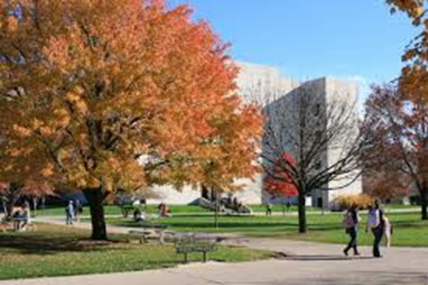
Much of the focus at IU Northwest is on student-faculty interactions and course-based pedagogical initiatives to improve student engagement and performance. While co-curricular engagement may be low, IU Northwest students report positive interactions with faculty and peers in the classroom. Results like these assist in both acknowledging the work faculty put into creating an engaging classroom as well as finding areas for future curricular improvement. One area the institution is exploring is campus climate and cross-cultural development.

Recently classified as a Hispanic-Serving Institution, IU Northwest has a diverse student population. And while many may think having a diverse student population automatically means inclusion, NSSE results show there is room for enhancing diverse interactions. First-year students report lower interactions with diverse others compared to seniors. While IU Northwest is urban, it also attracts students from rural and suburban locales. Many students come from segregated communities, and IU Northwest may be one of the first places they interact with students from another culture. It takes time to grow in this area and step out of your comfort zone as a student.

Even with this contextualized understanding of IU Northwest student engagement, there is still room to explore what IU Northwest students need. Moving forward, Novak has plans to use NSSE data to examine campus climate. This includes combining NSSE data with other survey and assessment data already available on campus as well as with data from focus groups—to shed light not only on students’ needs but also on the needs of the surrounding community of Gary.

Center for Postsecondary Research • Indiana University School of Education • 201 North Rose Avenue • Bloomington, IN 47405-1006
812-856-5824 | nsse@indiana.edu | nsse.indiana.edu | Twitter: @NSSEsurvey, @NSSEinstitute | Facebook: @NSSEsurvey | Blog: NSSEsightings.indiana.edu

